**MECH 328 Weekly Progress Report *Sept. 4 - 7***

Group: 10 Project Title: TrailRider 5.0

**Last Week’s Goals**:

1. To familiarize ourselves with the project documents and create target specifications
2. To begin initial research
3. Set-up online google drive for document storage
4. Create a preliminary Gantt chart to manage upcoming week’s timeline

**Last Week’s Activities**:

|  |  |  |  |
| --- | --- | --- | --- |
| Name | Activities | Hours Worked | |
| Last Week | Total |
| Andrea | * Found an article related to the project * Read the project and course guide document | 1 | 1 |
| Carson | * Found an article related to the project * Read the project and course guide document * Created weekly report | 2 | 2 |
| Julia | * Found an article related to the project * Read the project and course guide document * Created target specifications and preliminary Gantt chart for weekly report | 2 | 2 |
| Lukas | * Found an article related to the project * Read the project and course guide document | 1 | 1 |
| Ratthamnoon | * Found an article related to the project * Read the project and course guide document | 1 | 1 |
| Stephen | * Found an article related to the project * Read the project and course guide document | 1 | 1 |
| Total |  | 8 | 8 |

**Summary of progress**:

* Many resources have been compiled during class and the team is familiar with the project.
* A google drive has been created and organized into appropriate folders.
* A preliminary Gantt Chart and Target Specifications have been created.

**Assessment of Overall Progress:**

* The team has not yet met outside of class time. Meetings this week will facilitate productivity and allow the design process to begin.
* Modifications to the target specifications and Gantt Chart may occur in the next week.

**Goals for Next Week**:

1. To discuss team goals, expectations, strengths and weaknesses. Also to distribute tasks accordingly.
2. To work through an iteration of the design process from finalizing need statements to function generation.

**Action Items for Next Week**:

|  |  |  |
| --- | --- | --- |
| Name | Action(s) | Due Date(s) |
| Everyone | Buy a logbook | Sept. 9 |
| Everyone | Discuss team expectations, goals and strengths | Sept. 9 |
| Everyone | Determine who will be responsible for each action | Sept. 9 |
| TBD | Brainstorm needs for the rider, the sherpas, BCMOS, the public and search and rescue | Sep. 9 |
| TBD | Determine the current specifications for the Trailrider (cost, weight, length, width etc.) | Sept. 9 |
| TBD | Estimate the worst-case acceptable value for these specifications with justification | Sept. 11 |
| TBD | Create a high-level Gantt chart with important deadlines to work from | Sept. 9 |
| TBD | Compile interesting/useful resources from class list | Sept. 11 |
| TBD | Perform function decomposition on the Railrider based on needs | Sept. 11 |
| TBD | Begin brainstorming solutions to each function | Sept. 11 |

**Preliminary Gantt Chart from Microsoft Project:**

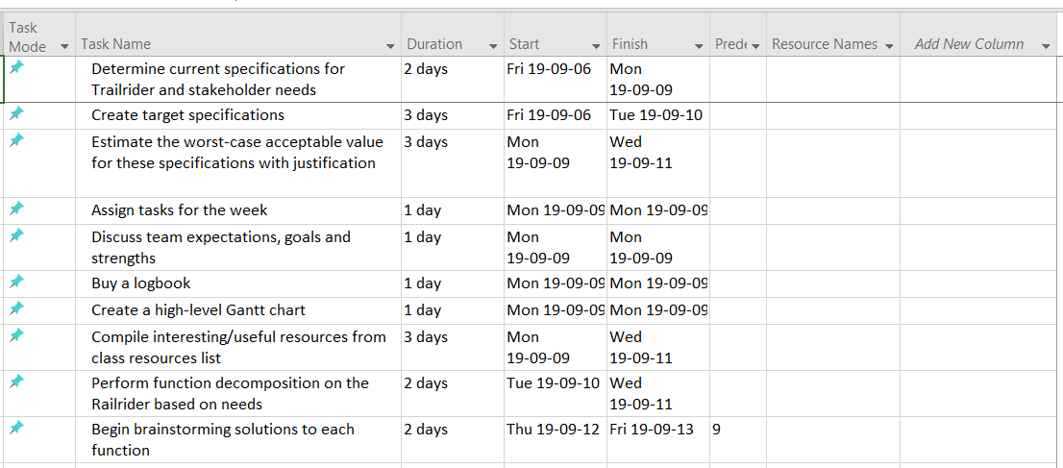

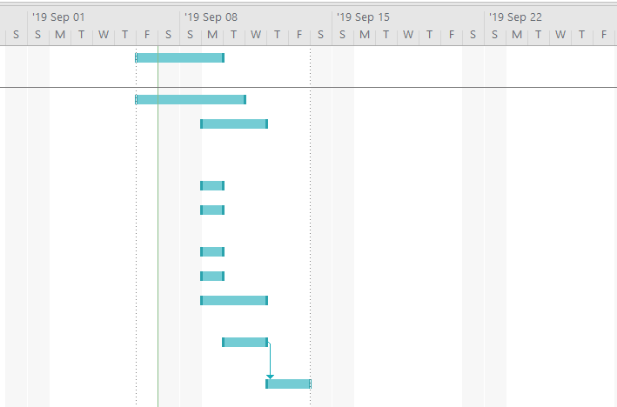

**Target Specifications:**

